Kyle Klausen

CSD325

Assignment3_2

06/04/25

Flowchart:

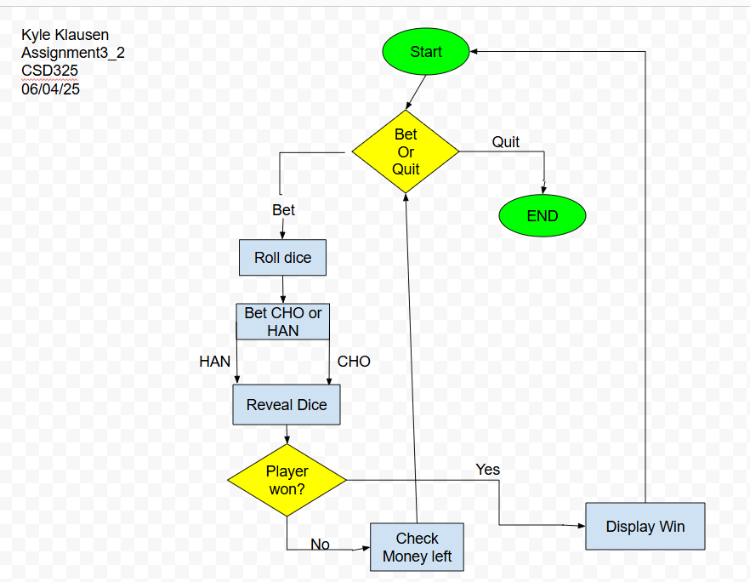

Code:

# Author: Kyle Klausen

# Date: 06/04/25

# Assignment3_2

"""Cho-Han, by Al Sweigart [al@inventwithpython.com](mailto:al@inventwithpython.com) The traditional Japanese dice game of even-odd. View this code at <https://nostarch.com/big-book-small-python-projects> Tags: short, beginner, game"""

import random, sys

JAPANESE_NUMBERS = {1: 'ICHI', 2: 'NI', 3: 'SAN', 4: 'SHI', 5: 'GO', 6: 'ROKU'}

print('''Cho-Han, by Al Sweigart [al@inventwithpython.com](mailto:al@inventwithpython.com)

In this traditional Japanese dice game, two dice are rolled in a bamboo cup by the dealer sitting on the floor. The player must guess if the dice total to an even (cho) or odd (han) number.

**\*\*Note:\*\*** If you roll a 2 or 7, you get a 10 mon bonus!''') # Added notice about bonus

purse = 5000

while True: # Main game loop.

# Place your bet:

print('You have', purse, 'mon. How much do you bet? (or QUIT)')

while True:

pot = input('> ')

if pot.upper() == 'QUIT':

print('Thanks for playing!')

sys.exit()

elif not pot.isdecimal():

print('Please enter a number.')

elif int(pot) > purse:

print('You do not have enough to make that bet.')

else:

# This is a valid bet.

pot = int(pot) # Convert pot to an integer.

break # Exit the loop once a valid bet is placed.

# Roll the dice.  
dice1 = random.randint(1, 6)  
dice2 = random.randint(1, 6)  
  
print('The dealer swirls the cup and you hear the rattle of dice.')  
print('The dealer slams the cup on the floor, still covering the')  
print('dice and asks for your bet.')  
print()  
print(' CHO (even) or HAN (odd)?')  
  
# Let the player bet cho or han:  
while True:  
 bet = input('JH: ').upper() # Changed input prompt to initials  
 if bet != 'CHO' and bet != 'HAN':  
 print('Please enter either "CHO" or "HAN".')  
 continue  
 else:  
 break  
  
# Reveal the dice results:  
print('The dealer lifts the cup to reveal:')  
print(' ', JAPANESE_NUMBERS[dice1], '-', JAPANESE_NUMBERS[dice2])  
print(' ', dice1, '-', dice2)  
  
# Check for 2 or 7 bonus:  
total = dice1 + dice2  
if total == 2 or total == 7:  
 print(f'You rolled {total} and got a 10 mon bonus!') # Added bonus message  
 purse += 10 # Add bonus to purse  
  
# Determine if the player won:  
rollIsEven = (total) % 2 == 0  
if rollIsEven:  
 correctBet = 'CHO'  
else:  
 correctBet = 'HAN'  
  
playerWon = bet == correctBet  
  
# Display the bet results:  
if playerWon:  
 print('You won! You take', pot, 'mon.')  
 purse = purse + pot # Add the pot from player's purse.  
 house_fee = int(pot * 0.12) # Changed house fee to 12%  
 print('The house collects a', house_fee, 'mon fee.') # Updated   
 house fee message purse = purse - house_fee  
else:  
 purse = purse - pot # Subtract the pot from player's purse.  
 print('You lost!')  
  
# Check if the player has run out of money:  
if purse == 0:  
 print('You have run out of money!')  
 print('Thanks for playing!')  
 sys.exit()

Screenshots of good run:

